**Ottawa Celebrates Intergenerational Day on June 1st with Music**

**By**: iGenOttawa

**June 1, 2021– Ottawa, Ontario**

For a third year, Ottawa joins cities across Canada in celebrating Intergenerational Day on June 1st. The pandemic has highlighted how connections between people of different generations are at the very foundations of our community. While we may not be able to gather in person on June 1st, we can still celebrate the benefits of building relationships across generations.

iGenOttawa has chosen *Music* as this year's theme for its power to raise spirits and strengthen community no matter the circumstances. iGenOttawa has been working with local organizations and musicians and is pleased to support the launch of [inspirational intergenerational song recordings on June 1st](https://www.igenottawa.ca/igen-day.html) which includes:

* A songwriting project led by local musician Craig Cardiff who held virtual songwriting workshops with students in the Ottawa-Carleton District School Board and participating older adults, turning their ideas about “good neighbours” into songs. The lead track entitled, “*What Makes a Good Neighbour*,” captures children and older adult voices celebrating the connections between people of different generations. (See Backgrounder below for more information)
* A virtual musical collaboration between OrKidstra and Ottawa’s Canadian Showtime Chorus**®** to create a special version of the song “*I’d Like to Teach the World to Sing (In Perfect Harmony).*” (See Backgrounder below for more information)
* Students at the Centre d’Excellence Artistique de l’Ontario (CEAO) at l’École Secondaire at Publique De La Salle offered 250 arts booklets and online music performances including the annual end of year gala to the residents of the Centre d’Accueil Champlain and Bruyère.

iGenOttawa hopes music will inspire people to connect with one another on June 1st and year-round in simple, meaningful ways, such as:

* + talking on the phone or organizing a video chat, adding a bit of music;
  + sending an email (including video or links to music they might enjoy);
  + sharing a physically distanced visit outside (and maybe bring along your instrument of choice!)

“Now more than ever, we need ways to connect. Just because we can’t be together, doesn’t mean we can't be connected and music is a great connector,”explains Christine Franklin, Co-Founder of iGenOttawa est. 2019.

  - 30 -

**Listen to the Songs**

* “*What Makes a Good Neighbour*” song created by students from the Ottawa- Carleton District School Board, local older adults, and local musician Craig Cardiff and his team [***Listen here***](https://soundcloud.com/craigcardiffmusic/sets/what-makes-a-good-neighbour)
* “*I’d Like to Teach the World to Sing (In Perfect Harmony)*” intergenerational song recording with virtual collaboration between OrKidstra and Canadian Showtime Chorus [***Listen here***](https://www.igenottawa.ca/igen-day.html)

**Additional Link**

* [Connected Canadians Blog](https://www.connectedcanadians.ca/blog-1/2018/5/26/music-and-tech-6-tools-you-or-your-grandmother-can-use): Music and Tech- 6 Simple Tools You and Your Grandmother Can Use

**Backgrounder**

**“Good Neighbours" Intergenerational Song Project**

As part of iGenOttawa’s Good Neighbours Ottawa campaign, students from the Ottawa-Carleton District School Board participated in a songwriting project on the theme, “What does it mean to be a good neighbour?" led by local musician Craig Cardiff and his team. This project, engaged classes at Featherston Drive Public School, Rockcliffe Park Public School, and North Gower Public School in virtual workshops, and involved older adults in the community, including residents at St. Patrick’s Home. Six songs were created, filled with heartwarming interviews and singing. The lead “intergenerational song” entitled, “*What Makes a Good Neighbour*," captures younger and older voices in celebration of connections between people of different generations. Students from Kindergarten to grade 12 wrote, recorded, and produced original songs inspired by a collective of voices responding to the need for connection during the COVID-19 Pandemic.

**Canadian Showtime Chorus® and OrKidstra Song Project**

A virtual collaboration between singers from two Ottawa music-based organisations, OrKidstra and the Canadian Showtime Chorus**®**, has produced an intergenerational version of the iconic song *“I’d Like to Teach the World to Sing (In Perfect harmony)”* with words and music by B. Backer, B. Davis, R. Cook and R. Greenaway; arranged by R. E. Schram*.* OrKidstra is a social development program that empowers kids, ages 5-18, from under-served Ottawa communities by teaching life skills – such as teamwork, commitment, respect and pride in achievement – through the universal language of music. Canadian Showtime Chorus® is a competitive women’s singing group, specializing in 4 part a cappella harmonies in the barbershop style. Formed in 1982, the Canadian Showtime Chorus**®** ranks in the top 18 of more than 500 Sweet Adelines choruses worldwide.

**History of Intergenerational Day (Est. in 2010)**

Intergenerational Day Canada started in British Columbia in 2010 to celebrate the value of connections between generations. Since then, more than 100 cities have officially recognized the day. For the third year in a row, Ottawa will be joining other cities across Canada in proclaiming June 1st as Intergenerational Day – to raise awareness of the power of simple intergenerational connections and to celebrate the positive influence intergenerational connections have on eliminating isolation and loneliness. It is a day to celebrate all the good things that are presently taking place between generations in the community as well as to promote activities to encourage individuals of different ages to connect.

**Contact for More Information and Interviews:**

|  |  |
| --- | --- |
| **Nicola Maule**  Communications, iGenOttawa  613-371-8182  [nicolamaule@gmail.com](mailto:nicolamaule@gmail.com) | **Facebook:** [**@iGenOttawa**](https://www.facebook.com/iGenOttawa)  **Twitter:** [**@iGenOttawa**](https://twitter.com/iGenOttawa)  **Website:** [iGenOttawa.ca](http://www.igenottawa.ca) |

**Photos for Use**

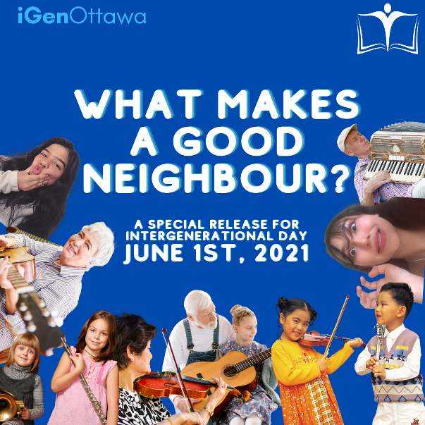

**Photo Cutline:**  A new song “*What Makes a Good Neighbour*” by students from ~~t~~he Ottawa-Carleton District School Board and participating older adults, led by local musician Craig Cardiff, will be released on June 1st to celebrate Intergenerational Day.

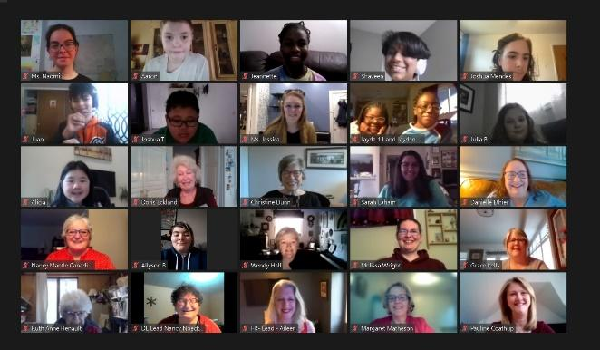

**Photo Cutline:** Singers from OrKidstra and the Canadian Showtime Chorus will launch a joint collaboration of the song “*I’d Like to Teach the World to Sing (In Perfect harmony)*” to celebrate Intergenerational Day on June 1st.

**Contributors**

|  |  |  |
| --- | --- | --- |
| [ocdsb.png](https://ocdsb.ca/) | [cid:995A73E8-F30E-41A9-8211-13F6EC5D6C27](https://canadianshowtimechorus.com/) |  |
| [unknown.png](https://ceao.cepeo.on.ca/) |  | [Graphical user interface, text, application  Description automatically generated](https://cepeo.on.ca/) |
| **Bryere.tiff** | cid:image004.jpg@01D74CB0.6D493BB0 |  |
|  |  |  |